DATAWARE HOUSING AND DATA MINING

ASSIGNMENT 4

GROUP MEMBERS

MUHAMMAD BILAL AHMED (FA20-BCS-041)

MUHAMMAD SALMAN (SP20-BCS-131)

1. **OLAP cubes**

OLAP stands for Online Analytical Processing Server. It is a software technology that allows users to analyze information from multiple database systems at the same time.  It is based on multidimensional data model and allows the user to query on multi-dimensional data.

1. **OLAP operations**

There are five basic analytical operations that can be performed on an OLAP cube:

* Drill down
* Roll up
* Slicing
* dicing

1. **Drill down**

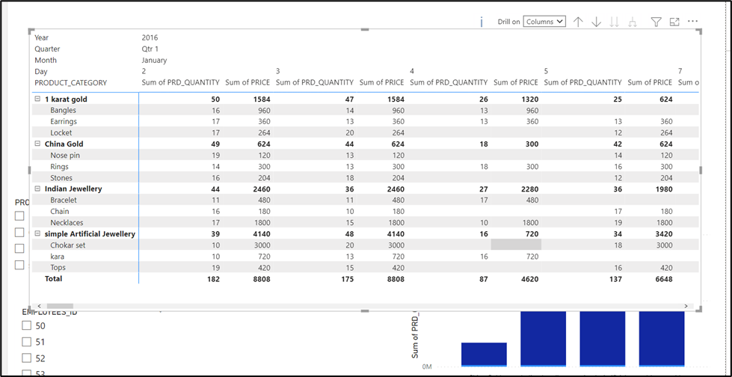

Drill down means a way of viewing related items of a Dimension as defined in a Hierarchy by expanding Members to access a more detailed data range.

We can drill down row wise or column wise.

In row wise drill down operation is performed by moving down in the concept of hierarchy of product dimension. Categories - > products

In column wise drill down operation is performed by moving down in the concept of hierarchy of time dimension. Year -> Quarter -> month -> day

1. **Roll up**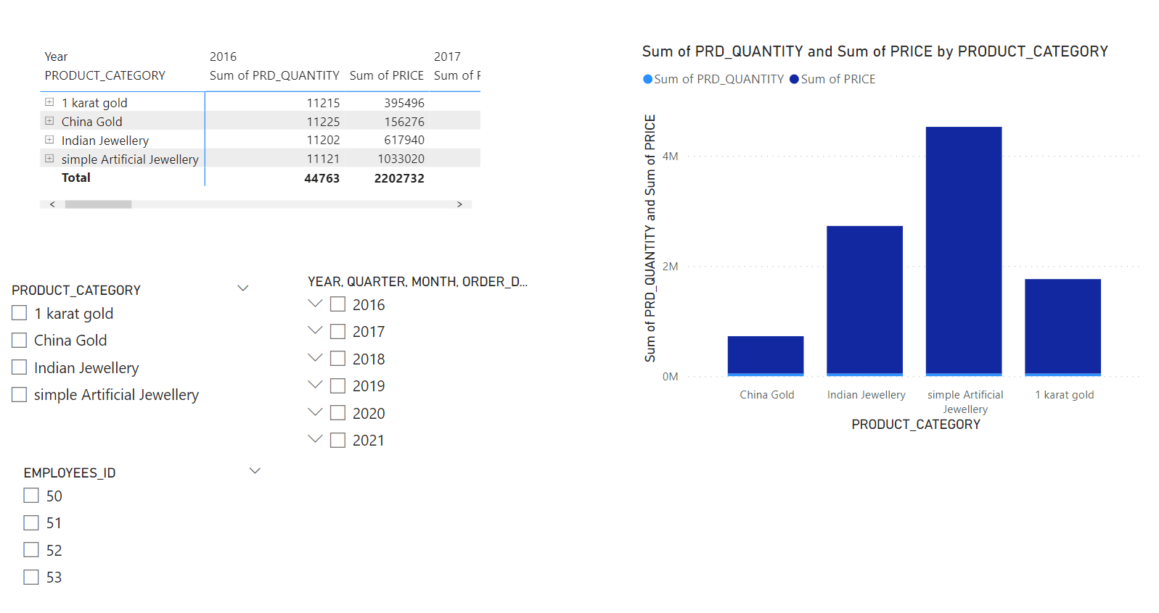

It is just opposite of the drill-down operation. It performs aggregation on the OLAP cube. It can be done by:

* Climbing up in the concept hierarchy
* Reducing the dimensions

1. **Slicing**

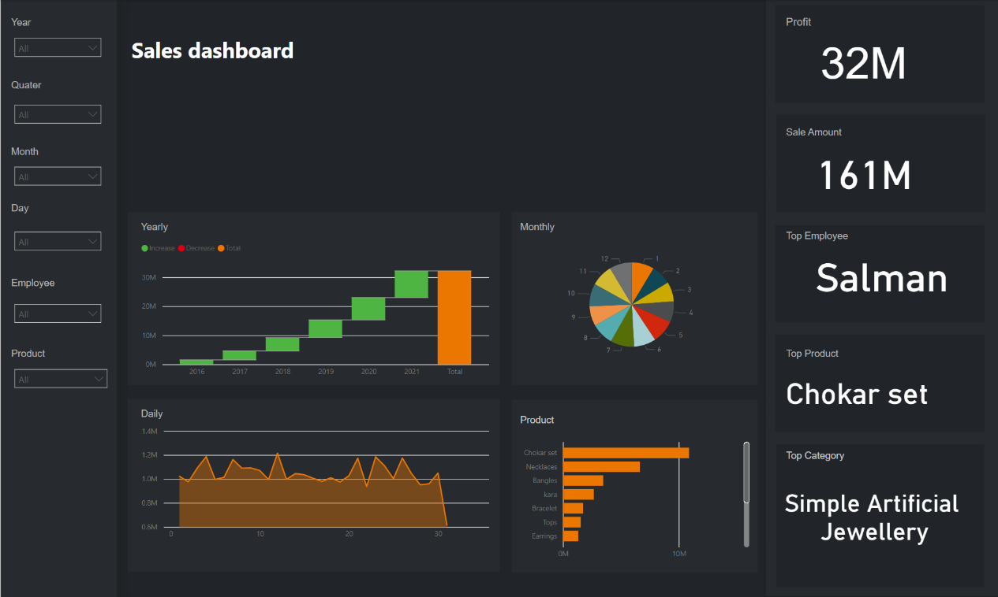

It selects a single dimension from the OLAP cube which results in a new sub-cube creation. In the cube given in the overview section like we can perform slicing time dimension by selecting year 2016 only.

1. **Dicing:**

It selects a sub-cube from the OLAP cube by selecting two or more dimensions. In above example we can perform dicing by selecting year 2016, month June and day 20 to overview our sales.

1. **Cube creation in power bi**

For roll up and drill down we can select matrix in visuals portion. We can create hierarchies either column wise or row wise according to own choice.

For slicing and dicing we use slicers. Slicers in Power BI are a type of on canvas visual filters. The slicers enable a user to sort and filter a packed report and view only the information they want. Unlike filters, the slicers are present as a visual on the report and let a user select values as they are analyzing the report. For instance, if you have a sales analysis report, you can make a slicer for years. From that slicer, you can select the year for which you want to see the sales metrics. The report visuals will automatically change showing the information for that year.

Top Microsoft power bi visuals are

1. Area charts
2. Line charts
3. Bar chart
4. Column chart
5. Combo charts
6. Pie charts
7. Donut chart
8. Card
9. Matrix
10. Water fall charts